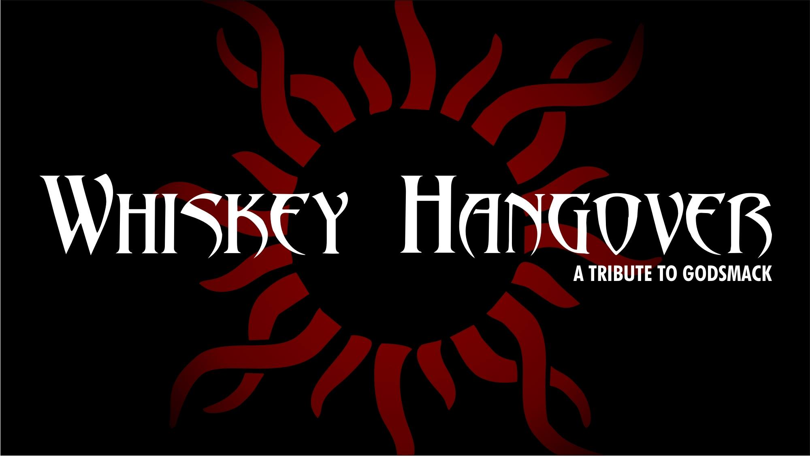

WHISKEY HANGOVER PERFORMANCE RIDER

A. BILLING & ADVERTISING

1. WHISKEY HANGOVER’s name and logo photo shall be included on all print ads, radio ads, flyers and social media for this engagement as the Headliner/Main Event for _______________________ (date and name of event).

B. TICKET SALES

1. A minimum of ten (10) Complimentary Tickets/Wrist Bands are to be set aside for the sole and exclusive use by WHISKEY HANGOVER.

C. PROMOTER REPRESENTATIVE

1. A promoter representative must be present before load in starts and remain until load out is finished.

2. A cell number for promoter representative and middle agent are to be provided to WHISKEY HANGOVER’s Stage Manager when date is confirmed.

D. TECHNICAL REQUIREMENTS

1. WHISKEY HANGOVER will have 100% control over their show, production and backstage Area.

2. Purchaser agrees to provide sufficient VIP parking for WHISKEY HANGOVER’S vehicles and production vehicles.

E. STAGE REQUIREMENTS:

1. PURCHASER agrees to provide a safe, level, water proof and solid stage.

F. LOADERS and STAGEHANDS

1. At the designated load in time, PURCHASER agrees to ensure that a minimum of two (2) Loaders and Stagehands be present and available to unload and move ARTIST’s equipment at the exclusive direction of WHISKEY HANGOVER’S Stage Manager.

These stagehands will also need to be available for set change(s).

1. Two (2) Loaders and Stagehands must be present to strike and load WHISKEY HANGOVER’S equipment at the completion of engagement.

G . SOUND CHECK

1. At the time agree upon by WHISKEY HANGOVER’S Stage Manager and PURCHASER, WHISKEY HANGOVER will sound check and will have sole and exclusive control of the stage, backstage, and all sound/light production for as long as is reasonably necessary to ensure the highest quality performance.

2. WHISKEY HANGOVER reserves the right to clear the stage and/or remove any persons it deems necessary during WHISKEY HANGOVER’S sound check.

3. Upon setting the stage and completion of WHISKEY HANGOVER’S sound check, WHISKEY HANGOVER’S backline will not move. Support acts may set up in front of WHISKEY HANGOVER’S backline at the direction of WHISKEY HANGOVER’S Stage Manager.

H. SOUND SYSTEM

1. PURCHASER agrees to provide a high-quality sound system by a professional sound company that is approved by WHISKEY HANGOVER.

I. LIGHTING REQUIREMENTS

1. PURCHASER agrees to provide a professional concert lighting system.

2. WHISKEY HANGOVER’S Lighting Designer will provide direction on gel colors and overall light production so as long as it does not interfere with any headlining bands.

J. POWER REQUIREMENTS

1. PURCHASER agrees to provide power services adequate for any and all equipment and lights.

K. CATERING

1. The following items are to be given to WHISKEY HANGOVER’S Stage Manager, Carlos Melgoza by 2:00 P.M. on the day of the show or as otherwise directed by WHISKEY HANGOVER’S Stage Manager.

a. One (1) full sized Bottle of Vodka (Absolut or equivalent)
b. One (1) full sized Bottle Makers Mark
c. Twelve (12) cans of Bud Light
d. Twelve (12) cans of Tecate Light
e. Twelve pack (12) cans of diet coke, (12) Sprite and (12) Coke
f. Twenty Four (24) bottles of Spring Water (12- 16 ounce bottles).
g. Six (6) pack of Fruit (red) Gatorade
h. Four pack of White Monster Energy Drinks

L. COMPENSATION

- WHISKEY HANGOVER will be paid a total of $00 (_______________ DOLLARS AND NO/100). Half of the payment shall be payable upon arrival and the rest immediately following their performance.

M. FORCE MAJEURE
“Force Majeure" means an event beyond the control of the Authority and the Operator, which prevents a Party from complying with any of its obligations under this Contract, including but not limited to:
- act of God (such as, but not limited to, fires, explosions, earthquakes, drought, tidal waves and floods);
- war, hostilities (whether war be declared or not), invasion, act of foreign enemies, mobilization, requisition, or embargo;
- rebellion, revolution, insurrection, or military or usurped power, or civil war;
- contamination by radio-activity from any nuclear fuel, or from any nuclear waste from the combustion of nuclear fuel, radio-active toxic explosive, or other hazardous properties of any explosive nuclear assembly or nuclear component of such assembly;
- riot, commotion, strikes, go slows, lock outs or disorder, unless solely restricted to employees of the Supplier or of his Subcontractors; or
- acts or threats of terrorism.
N. CONSEQUENCES OF FORCE MAJEURE
1. Neither the Authority nor the Operator shall be considered in breach of this Contract to the extent that performance of their respective obligations (excluding payment obligations) is prevented by an Event of Force Majeure that arises after the Effective Date.
2. The Party (the “Affected Party”) prevented from carrying out its obligations hereunder shall give notice to the other Party of an Event of Force Majeure upon it being foreseen by, or becoming known to, the Affected Party.
3. If and to the extent that the WHISKEY HANGOVER is prevented from executing the Services by the Event of Force Majeure, while WHISKEY HANGOVER is so prevented then WHISKEY HANGOVER shall be relieved of its obligations to provide the Services but shall endeavor to continue to perform its obligations under the Contract so far as reasonably practicable.
4. If and to the extent that WHISKEY HANGOVER suffers a delay during the Construction Period as a result of the Event of Force Majeure then it shall be entitled to an extension for the Time for Completion in accordance with Sub-Clause.
5. If an Event of Force Majeure results in a loss or damage to the Facility, then WHISKEY HANGOVER shall rectify such loss or damage to the extent required by the Authority, PROVIDED that any Cost of rectification (less any insurance proceeds received by WHISKEY HANGOVER for the loss or damage) is borne by the Authority (WHISKEY HANGOVER has taken reasonable steps to mitigate the Cost).
O. OPTIONAL TERMINATION, PAYMENT AND RELEASE
1. Irrespective of any extension of time, if an Event of Force Majeure occurs and its effect continues for a period of [180] days, either the Authority or the Operator may give to the other a notice of termination. [If Authority is paying fee during Force Majeure, then Operator should not have a termination right, he is being paid.], which shall take effect [28] days after the giving of the notice. If, at the end of the [28]-day period, the effect of the Force Majeure continues, the Contract shall terminate.
2. After termination under this Sub-Clause WHISKEY HANGOVER shall comply with Sub-Clause [termination provisions] and the Authority shall pay WHISKEY HANGOVER the full amount of this contract plus any damages.
By signature below I affirm that I have read, understand and agree to the foregoing. I also understand that WHISKEY HANGOVER is a Rock Band and is very loud.

PURCHASER
Date: ____/_____/_____
Signed: _________________________________________
Printed Name ______________________________________
Management:
DeCasper Management Group
(832) 526-5783
david@decasper.com

For:
WHISKEY HANGOVER
Date: ___/____/_____
Signed: _________________________________________
Printed Name ______________________________________

